Technical Seminar on Fire Services Department Approval Process
By Ir SL Tse

In response to the concerns of processing time of statutory submission, three speakers from the Fire Services Department (FSD) were invited to explain the approval process in the seminar at The Hong Kong Polytechnic University (PolyU) on 28 November 2017. This event was jointly organized by BS and FE Divisions and supported by Department of Civil and Environmental Engineering of PolyU. More than 300 members attended.

Following a welcoming address by Ir Thomas Chung Chit-chun, Honorary Secretary of FE Division, Ir Wilson Tsang Sau-kit, Chairman of FE Division, delivered the opening speech. The seminar was divided into four parts and the speaker of the first part was Mr. Ho Chun-pang, Senior Station Officer of New Projects Division. He briefly described statutory role of FSD in the centralized processing system for the approval of general building plans (GBP). He also mentioned information required to be shown on the GBP and common non-compliance found in the fire service provisions.

The second speaker was Ir Midco Ma, Engineer of Fire Service Installations Division. She focused on the workflow for acceptance inspection of fire service installations and FSD’s work process on handling document submissions. She illustrated with examples on common irregularities found in document submissions and site inspections.

The third speaker was Mr. Leung Lok-hang, Senior Station Officer of Dangerous Goods Division. His presentation covered technical details and fire safety provision required for application for dangerous goods licence.

The last part was question-and-answer session. Members were very enthusiastic in raising questions on FSD’s acceptance criteria on different scenarios. After that, Ir Brian Cheng, Deputy Chairman of BS Division, gave the closing remarks. At the end of the seminar, Ir Chung thanked all the speakers, members of the organizing committee and participants for making the event such a great success.

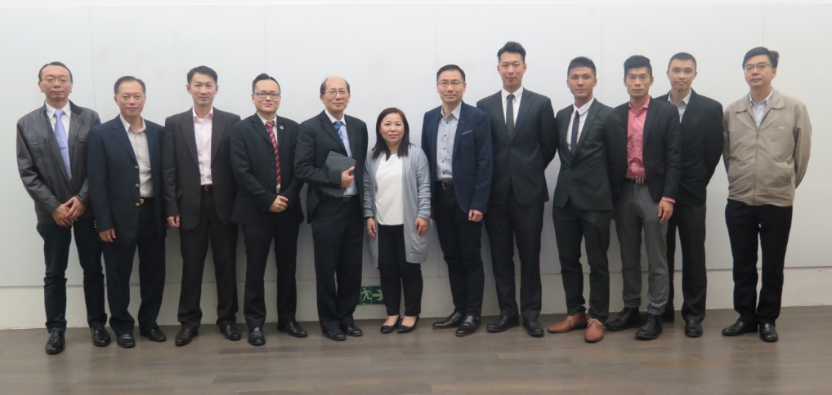
Members of the organizing committee and the speakers Ir Midco Ma (left 6th), Mr. Ho Chun-pang (right 5th) and Mr. Leung Lok-hang (right 4th)

